Tasks on Terraform-04

1) Watch terraform-04 video.

Completed watching video.

2) Execute the script shown in video.

Version Constraints:
===================
Changing in terraform providers version may get us into incompatibility issues.
By default, terraform will always try to download the latest version of provider available from registry.

To make sure to use the specific version provider we can add the provider block in configuration.

Example:
=======
terraform {
required_providers {
local = {
source = "hashicorp/local"
version = "2.3.0"
}
}
}

resource "local_file" "my-pet" {
filename = "pets.txt"
content = "I love cats!"
}
=========
version = "2.3.0" --> download the exact version
version = "!=2.3.0" --> will not use the mentioned version
version = "< 2.3.0" --> lesses than the mention version
version = "> 2.3.0" --> greater than the given version
version = "~> 2.3.0" --> specific version or higher version.

These are the versions currently available in the market for provider Local.

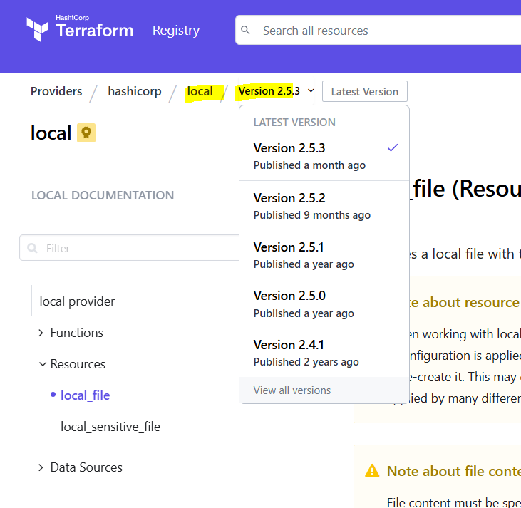

When we initialise using terraform init, it will install latest version of Plugins for providers.
There are chances of incompatibility, so need to upgrade to the required version.
Selecting Version 2.5.2 and trying to install local provider with different conditions.

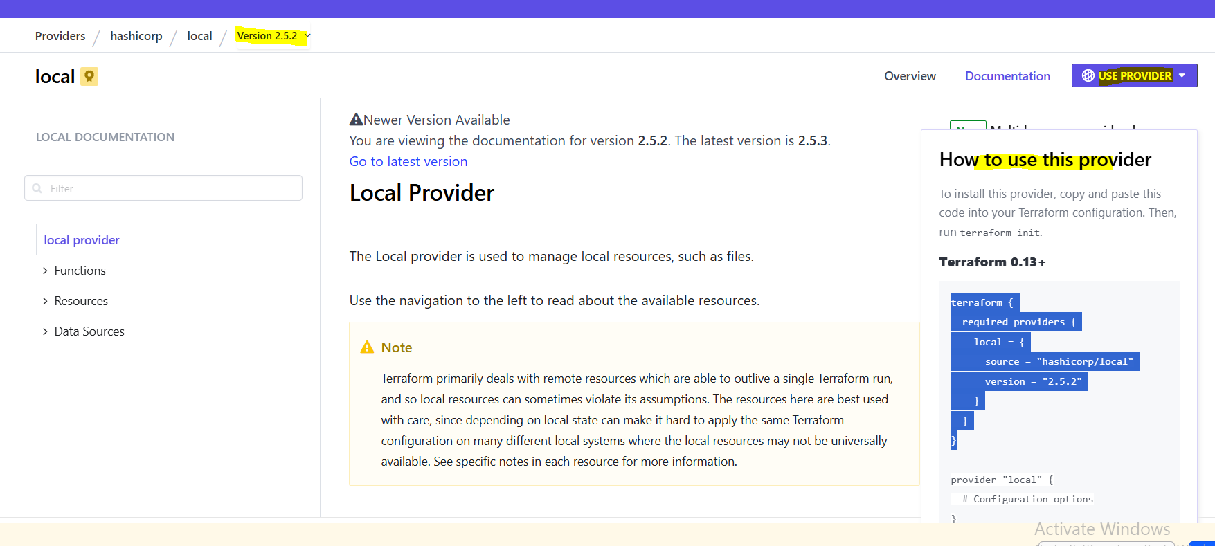

version = "2.5.2" download the exact version
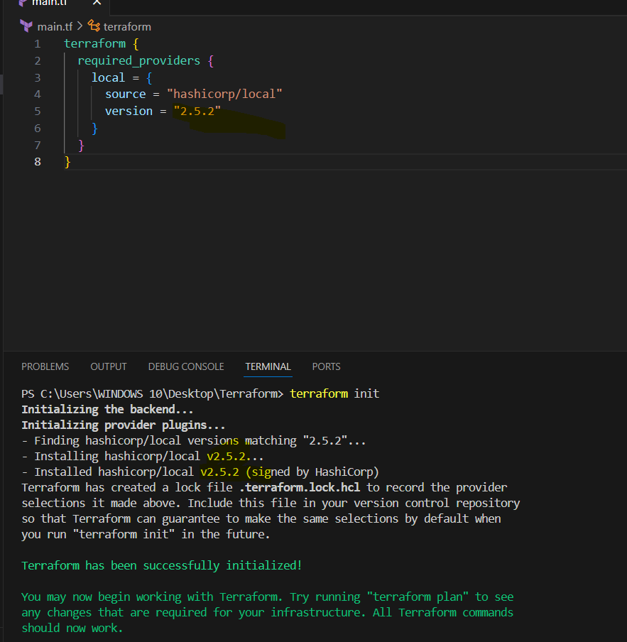

version = "!=2.5.2" will not use the mentioned version
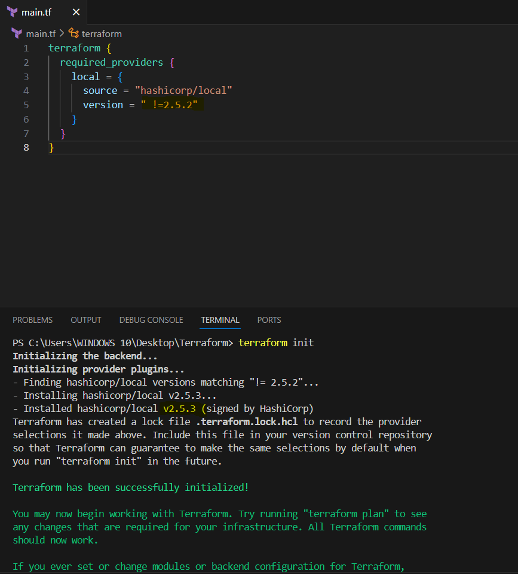

version = "< 2.5.2” lesser than the mention version

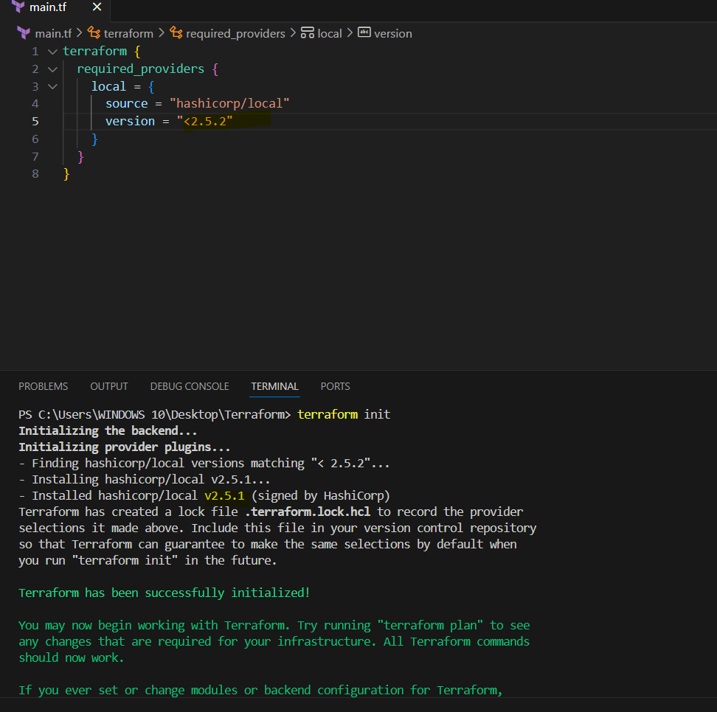

version = "> 2.5.2" greater than the given version
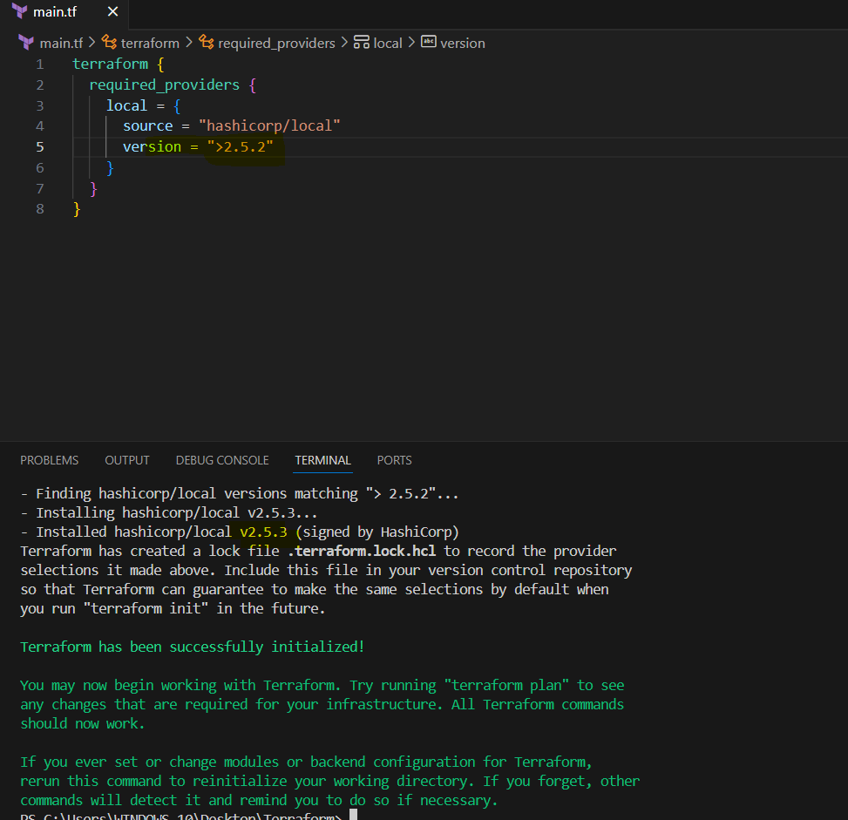

version = "~> 2.5.2" specific version or higher version.
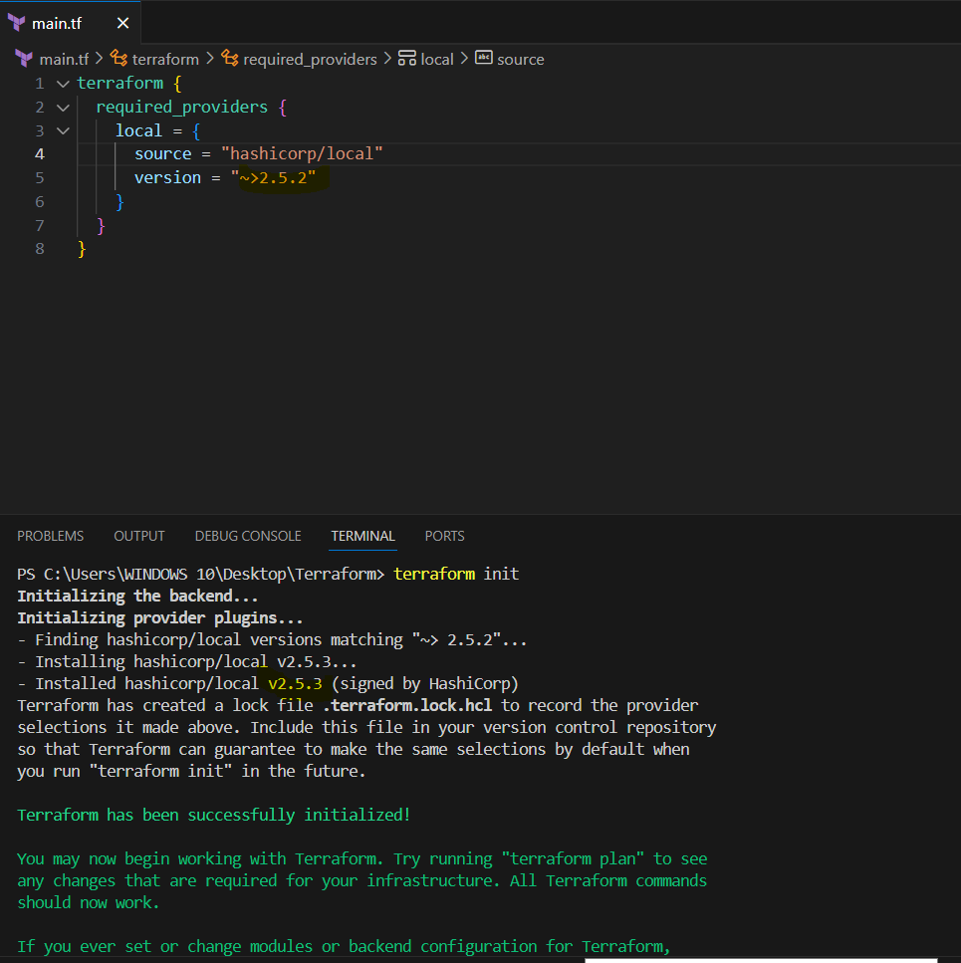

Using command terraform init -upgrade, by using this command we get 2 versions, one the existing and the second new initialised.

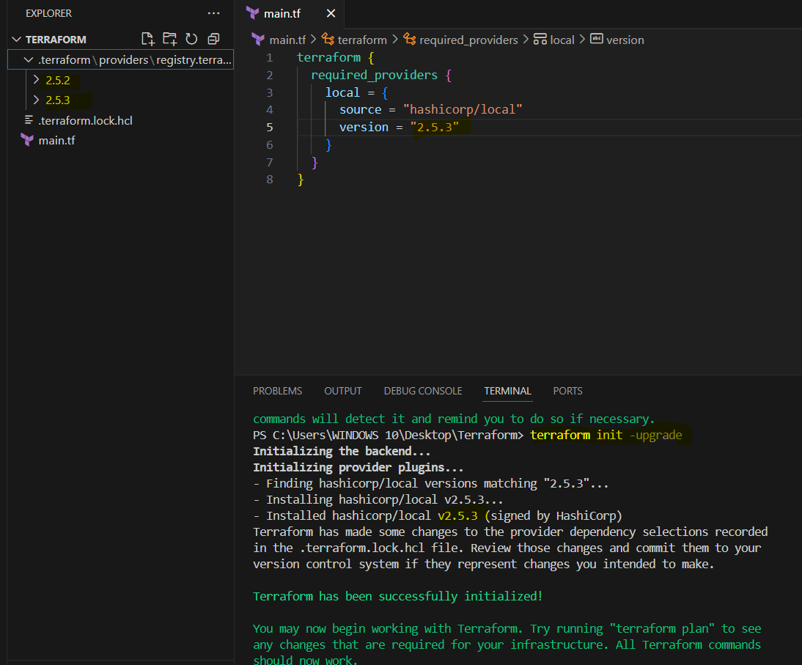

Data sources:
===========
Apart from terraform we have multiple other tools where the infra can be created.
Ex: ansible, salt, puppet, bash script, manual process.

Data sources are used to read the content of the infrastructure

for example if we want terraform to read the content of the file which has been created by any other tool.

create a file called in dogs.txt in the same terrafrom working directory.

main.tf
======

resource "local_file" "my-pet" {
filename = "pets.txt"
content = data.local_file.dog.content
}
data "local_file" "dog" {
filename = "dogs.txt"
}

Data block is used to read the infrastructure created from another tools.

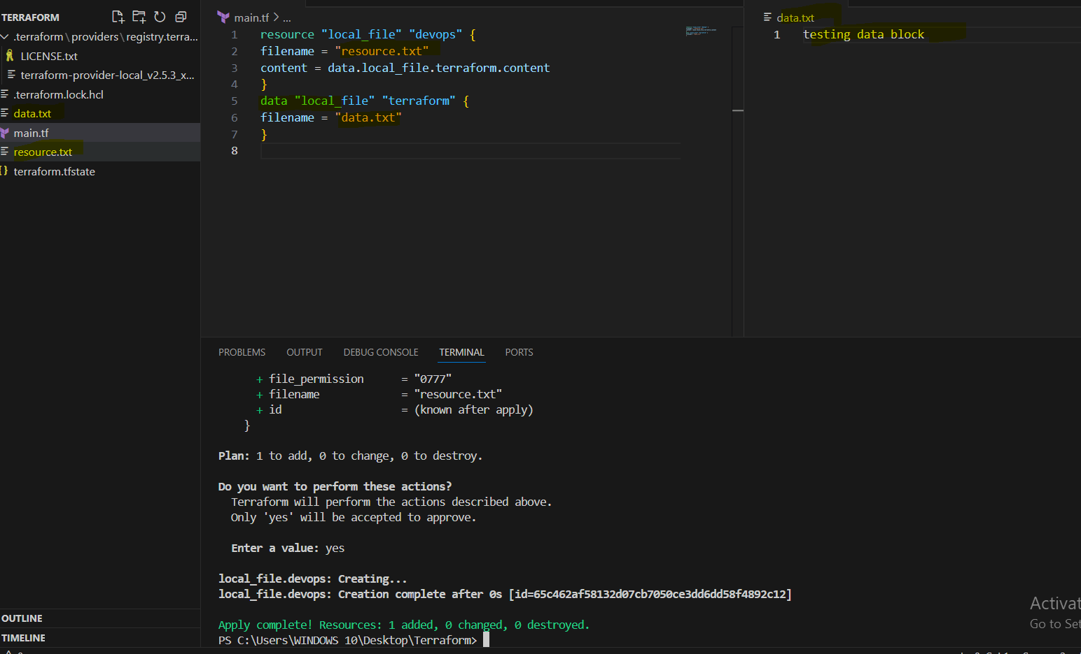
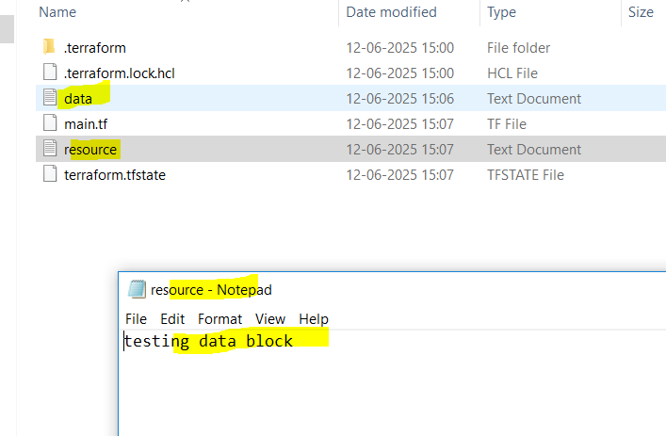

Difference between resources and data?

Resources starts with keyword resource
Resources are used to create, modify, delete the infra

Data source start with keyword data.
data sources are used to read the infrastructure.

Meta-Arguments:
==============
Meta arguments are used if we want to create multiple resources.
Meta arguments can be used within any resource block to change the behaviour of the resources.
Examples for meta arguments:

1) Depends_on (implicit & explicit)
2) lifecycle rules
3) Count
4) For_each

Example of count:
================
If we use count as 3 then it will create 3 files with pet[0],pet[1],pet[2]

resource "local_file" "my-pet" {
filename = "pets.txt"
content = "I love cats!"
count = 3
}

This is not the ideal way to use because these are getting replaced.

resource "local_file" "my-pet" {
filename = var.filename[count.index]
content = "I love cats!"
count = 3
}

variables.tf

variable "filename" {
default = [
"pets.txt"
"cats.txt"
"dogs.txt"
]
}
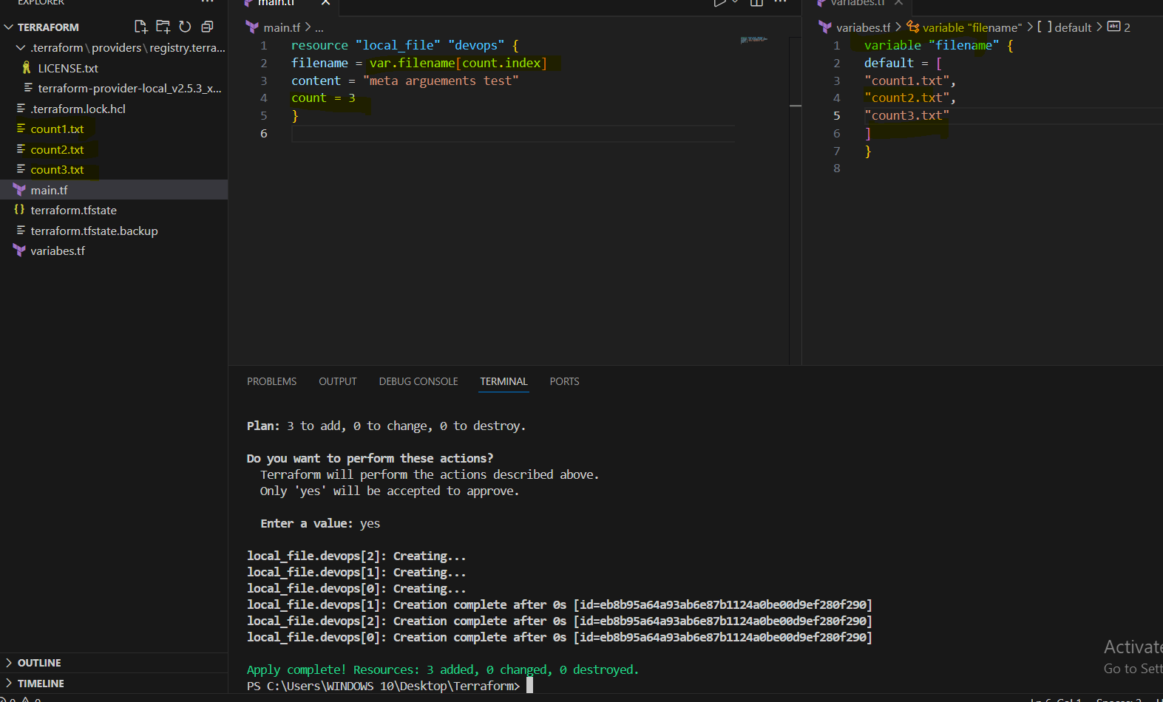

Still we have problem in the above configuration, if in future the list of variables then we need to change the count value manually.
to avoid this we can use the inbuilt length function in terraform.

resource "local_file" "my-pet" {
filename = var.filename[count.index]
content = "I love cats!"
count = length(var.filename)
}

variables.tf

variable "filename" {
default = [
"pets.txt"
"cats.txt"
"dogs.txt"
]
}

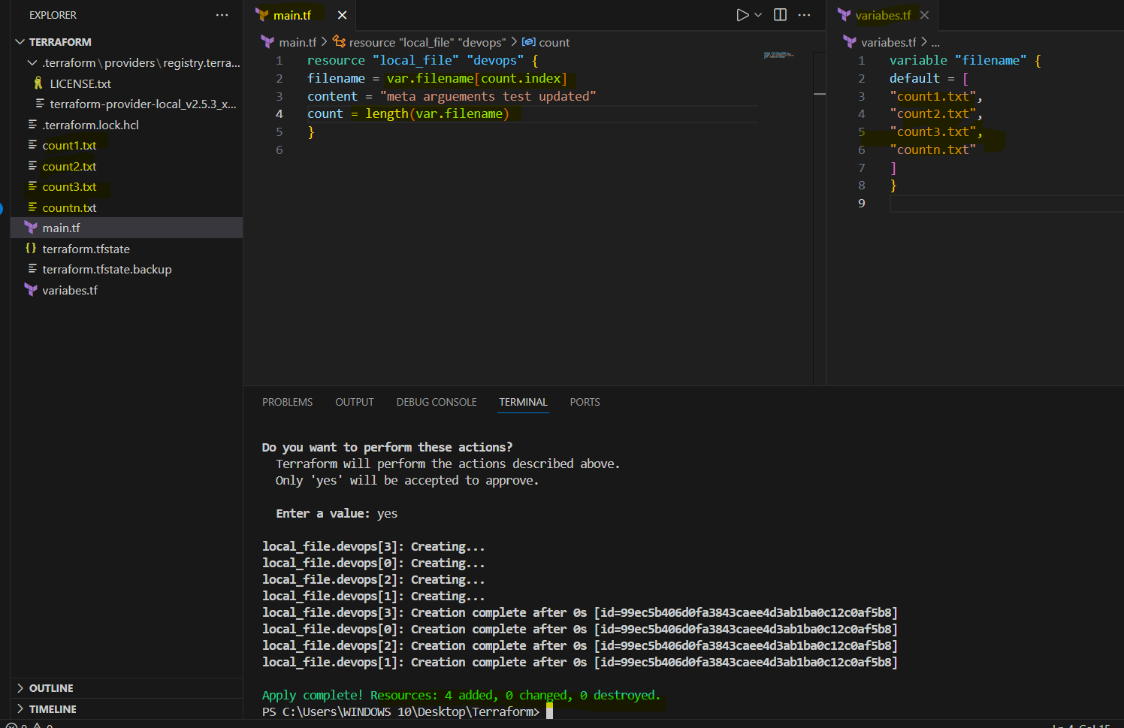

But when we want to update/destroy any one file then we will see unwanted results in count as count will store the output in list and works on index number.
To overcome the issue we have for_each meta argument.

Example of for_each:
====================
main.tf:

resource "local_file" "pet" {
filename = each.value
content = xyz
for_each = var.filename
}

variables.tf
============

variable "filename" {
type=set(string) --> list type will throw error for_each argument.
default = [
"pets.txt"
"cats.txt"
"dogs.txt"
]
}
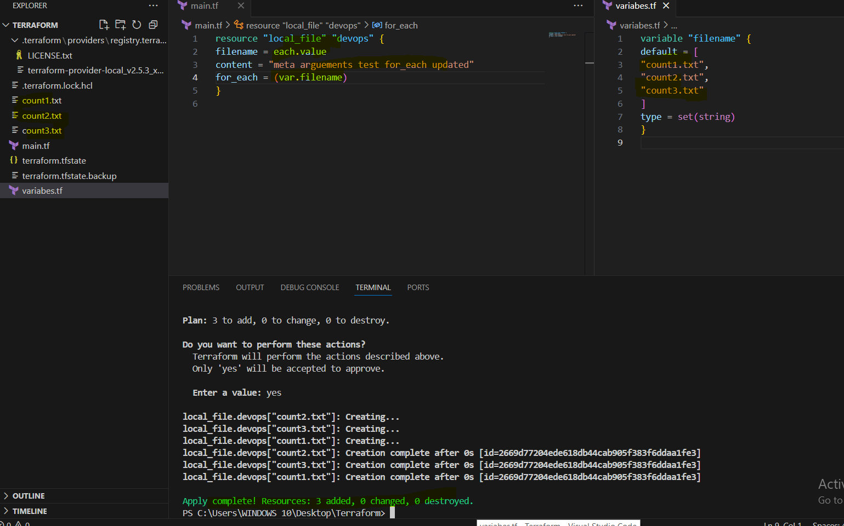

or if you want to use list variable then we can change the main.tf with toset inbuilt function.

main.tf:

resource "local_file" "pet" {
filename = each.value
content = xyz
for_each = toset(var.filename)
}

variables.tf
============

variable "filename" {
default = [
"pets.txt"
"cats.txt"
"dogs.txt"
]
}

Count will store the output as list and identified based on index number
foreach store the output as map and identified based on filename.
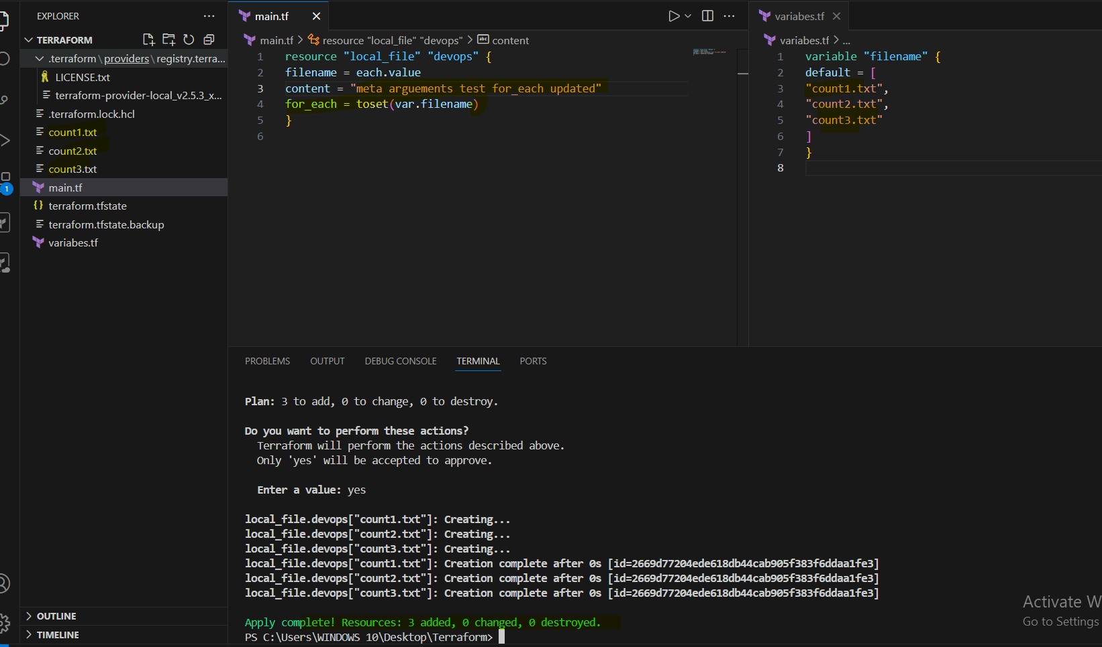

Terraform with AWS:
==================
--> first, we need to create a secret key and access key and configure with our terminal.
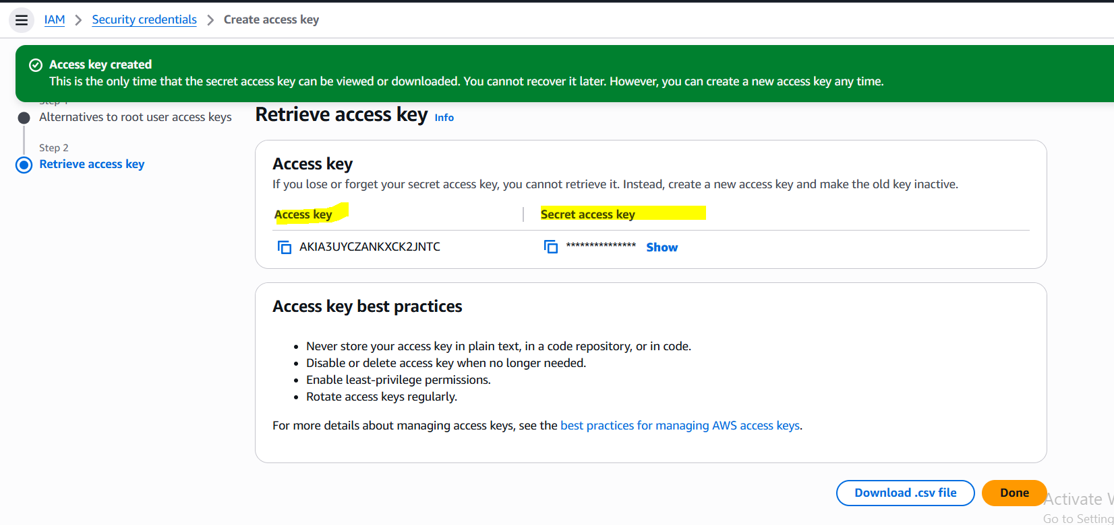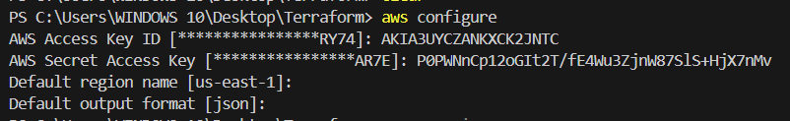

Example script to create aws iam user:
================================

resource "aws_iam_user" "Admin-user" {
name = "lucy"
tags = {
"description" = "Technical Team Lead"
}
}

First, we need to run command terraform init to install aws plugin.
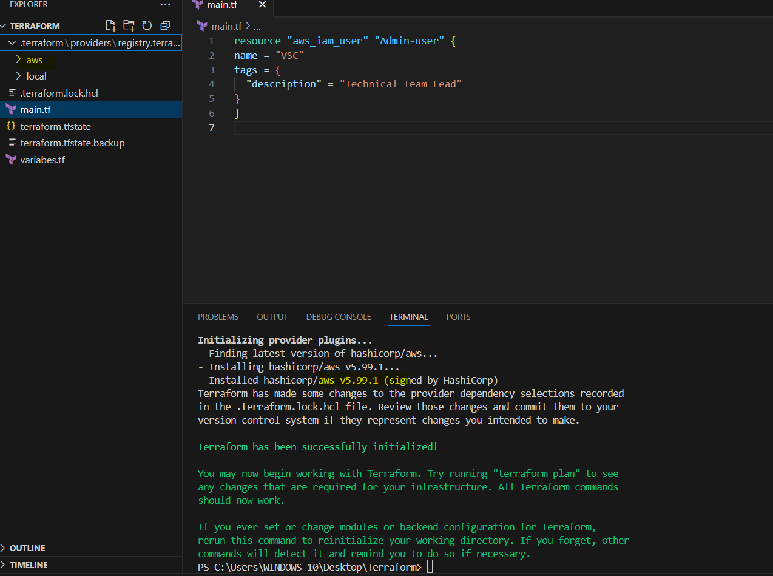

Then we can use terraform apply to create a IAM user with name VSC.

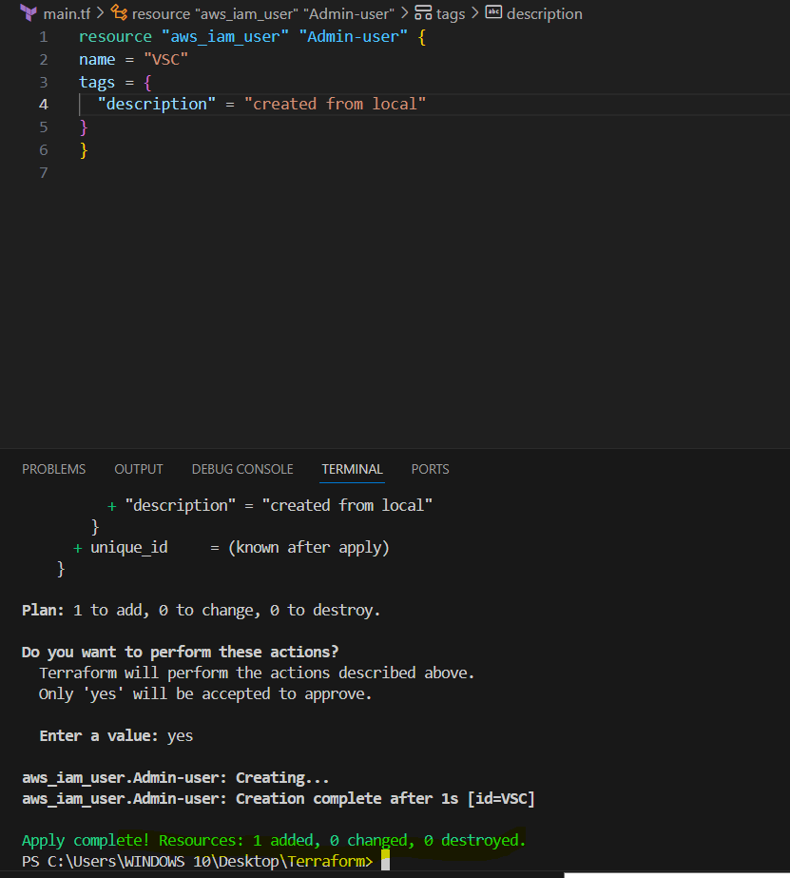

We can verify at console.
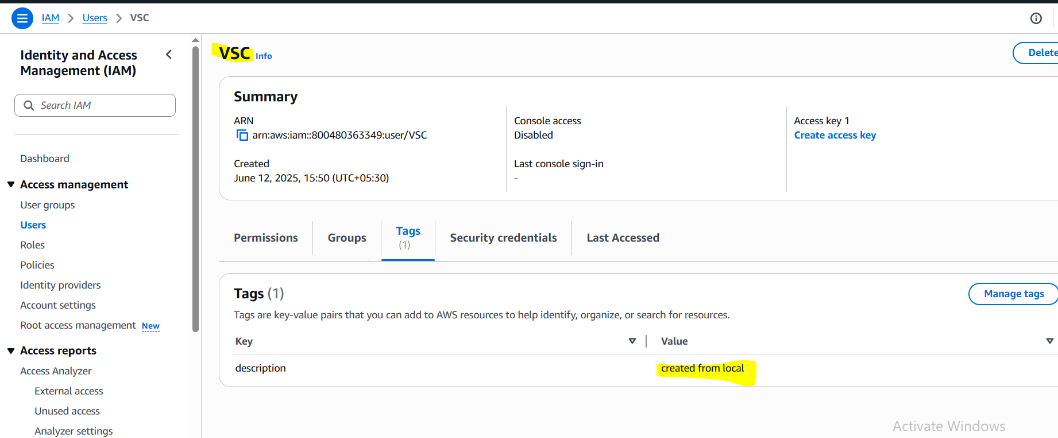

Example script to create iam user with policy attached to the user:
===================================================================

resource "aws_iam_user" "Admin-user" {
name = "lucy"
tags = {
"description" = "Technical Team Lead"
}
}
resource "aws_iam_policy" "adminuser" {
name = "AdminUsers"
policy = <<EOF
{
"Version": "2012-10-17",
"Statement": [
{
"Sid": "1234567890",
"Effect": "Allow",
"Action": "*",
"Resource": "*"
}
]
}
EOF
}

resource "aws_iam_user_policy_attachment" "lucy-admin-access" {
user = aws_iam_user.Admin-user.name
policy_arn = aws_iam_policy.adminuser.arn
}

By using this template, we are creating user and policy, then attaching the policy to user VSC- 2 and policy is Admin_user_permissions. We are giving full admin access to this user.
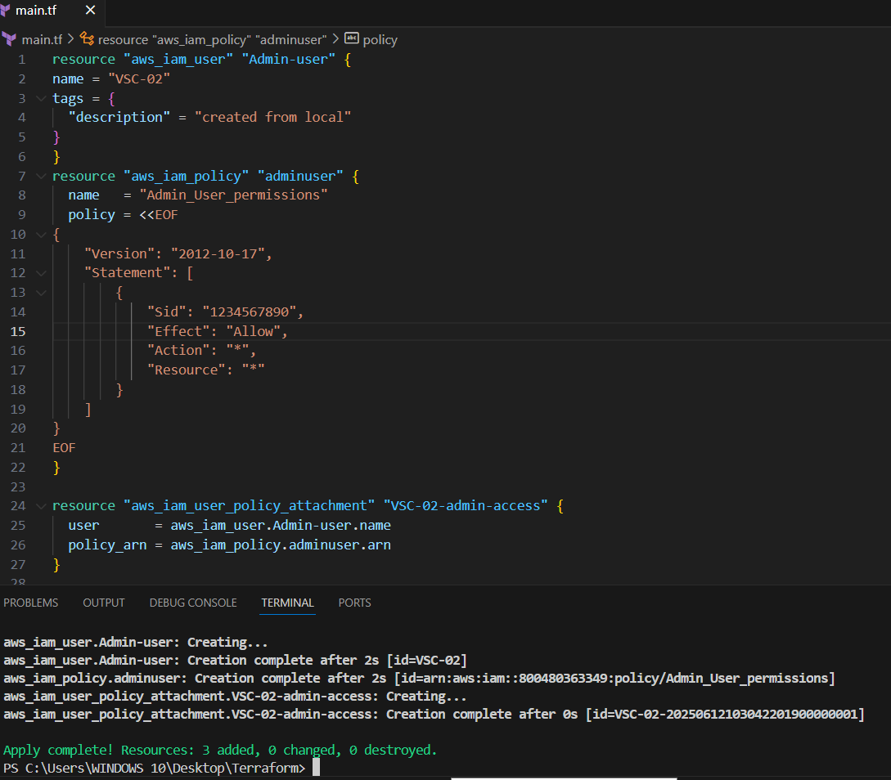

We can verify at console.
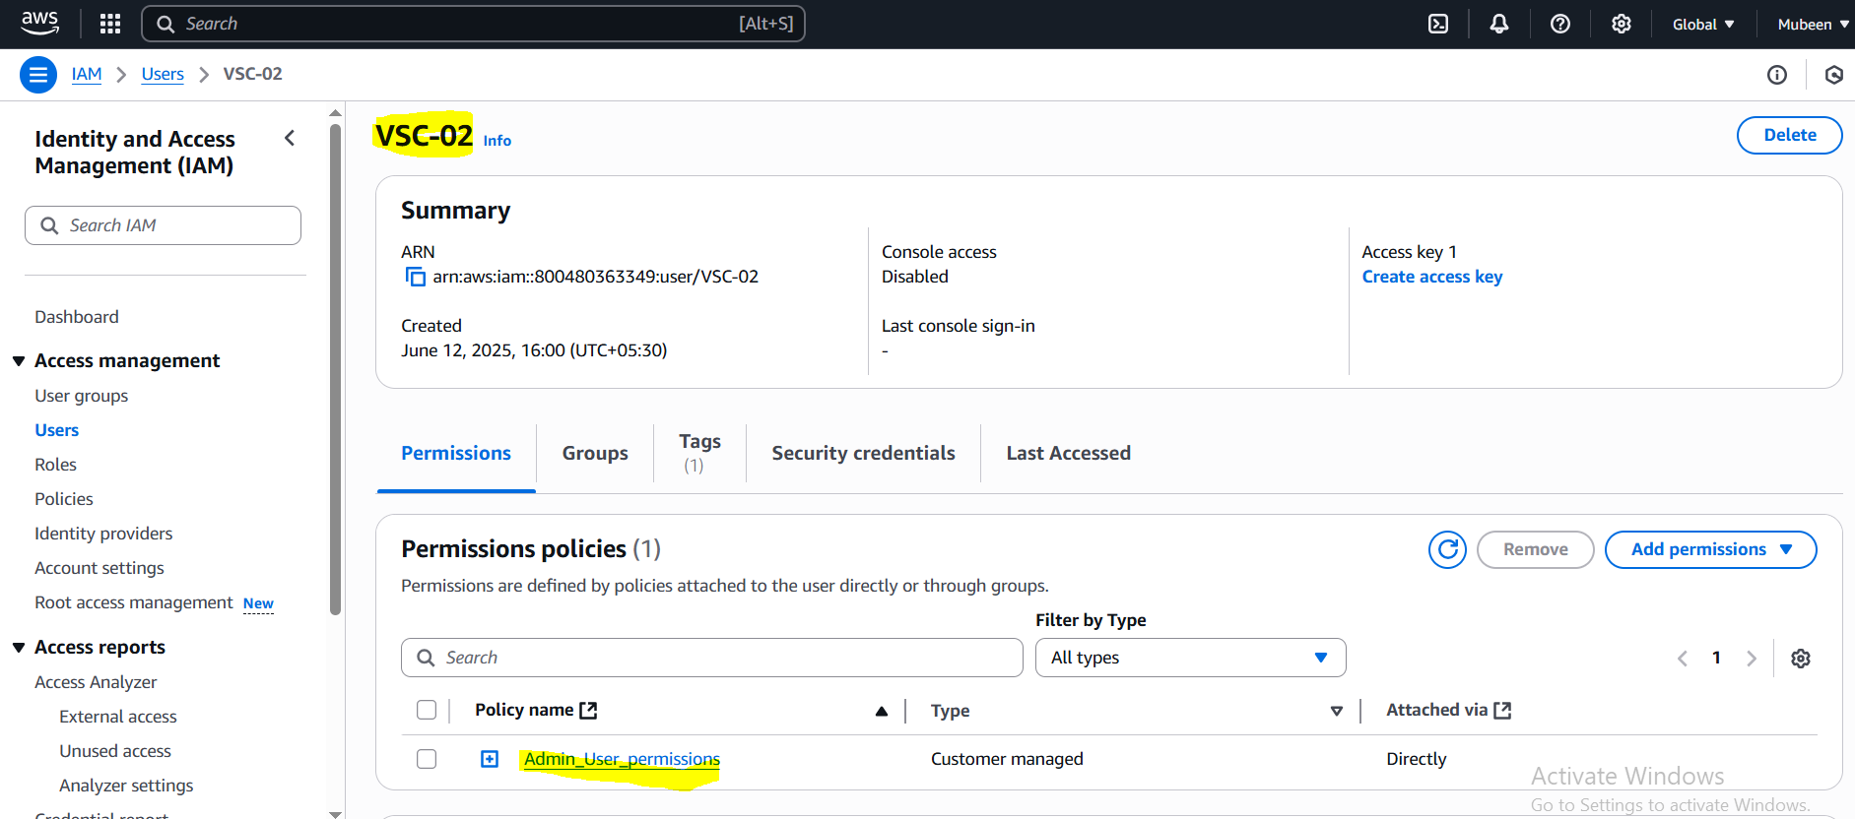

In the above example we have added the json policy using "heredoc syntax" and delimiters "EOF --> End of file" inside the main.tf.

we can also use them by saving the template in separate file and call that file in our main.tf.

Example:
=======
admin-policy.json
=================
{
"Version": "2012-10-17",
"Statement": [
{
"Sid": "1234567890",
"Effect": "Allow",
"Action": "*",
"Resource": "*"
}
]
}

main.tf:
======

resource "aws_iam_user" "Admin-user" {
name = "lucy"
tags = {
"description" = "Technical Team Lead"
}
}
resource "aws_iam_policy" "adminuser" {
name = "AdminUsers"
policy = file("admin-policy.json")
}

resource "aws_iam_user_policy_attachment" "lucy-admin-access" {
user = aws_iam_user.Admin-user.name
policy_arn = aws_iam_policy.adminuser.arn
}

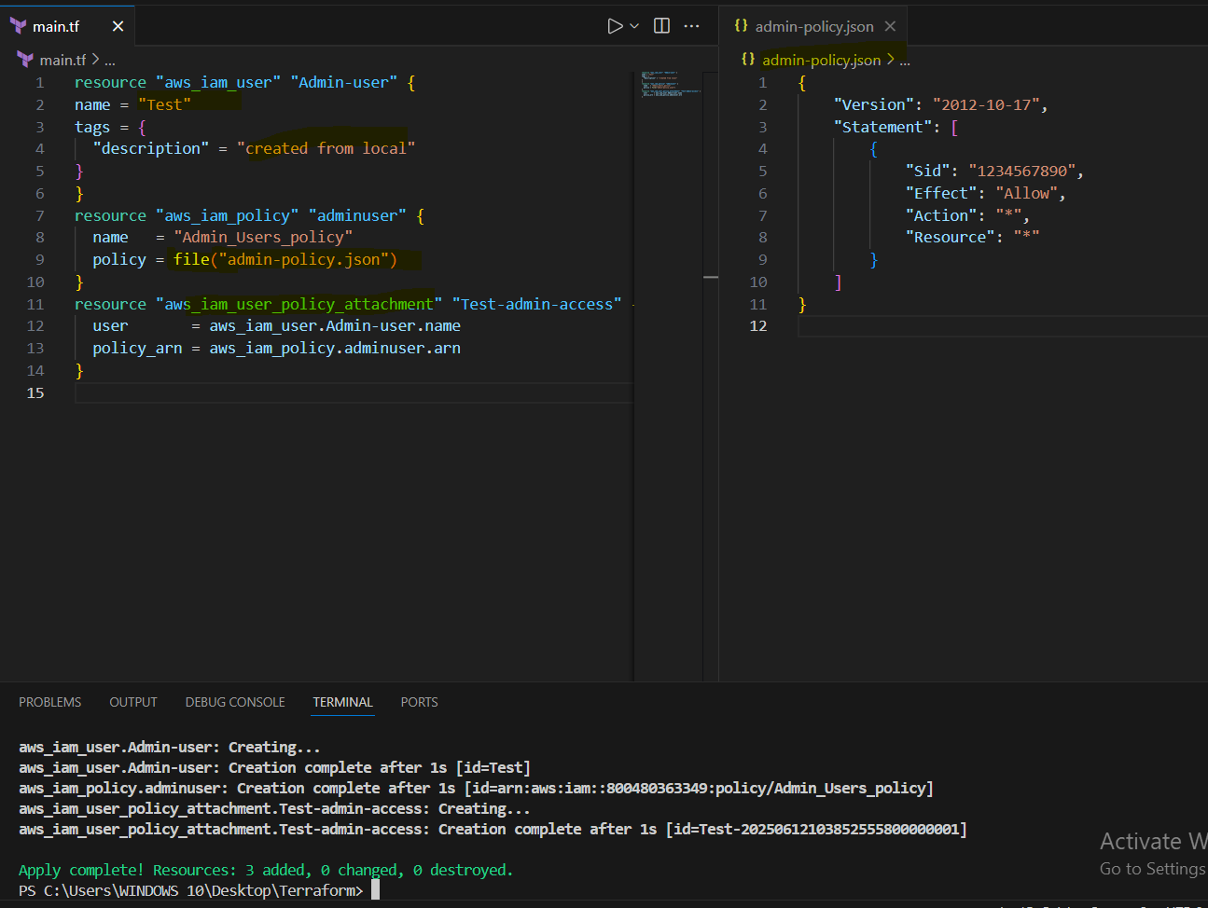

Verifying at console.
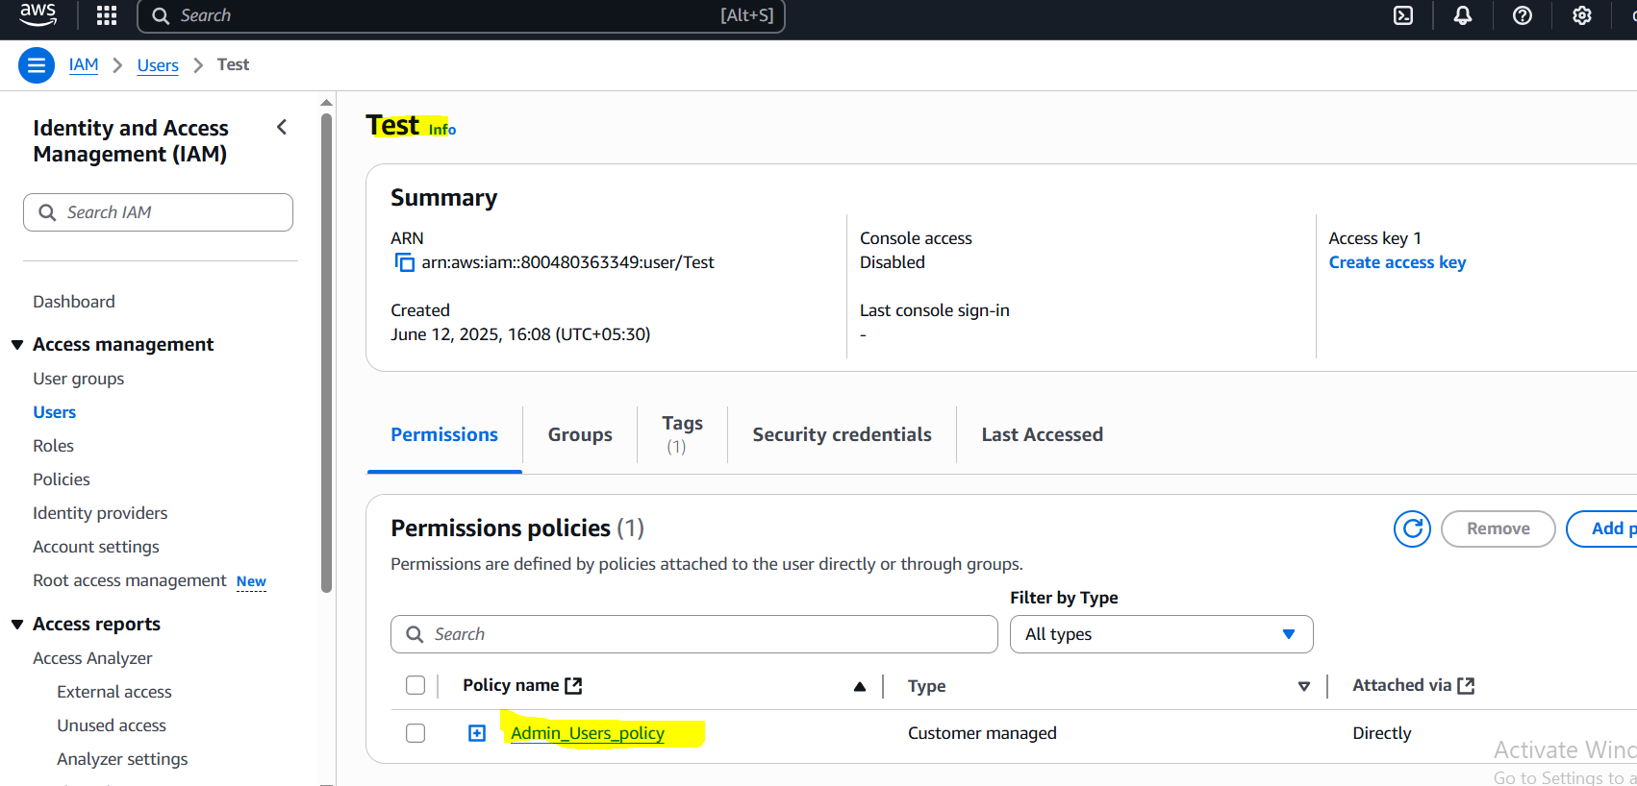

3) Integrate terrafrom in jenkins using Terraform plugin.

We need to install Terraform plug in our Jenkins.
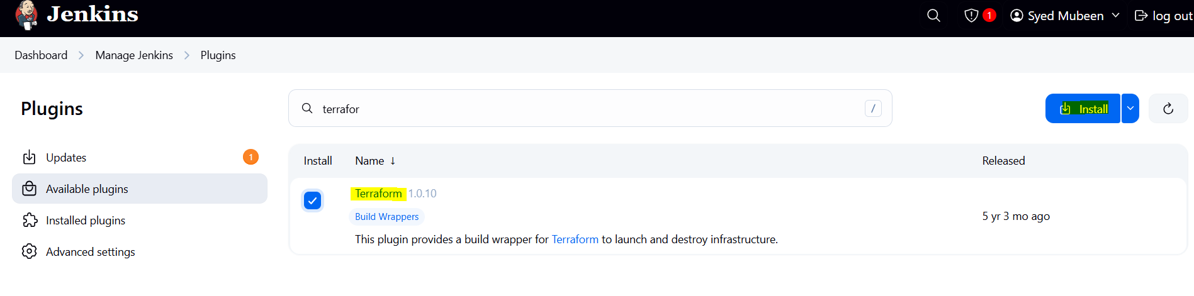

Need to configure Terraform in tools.
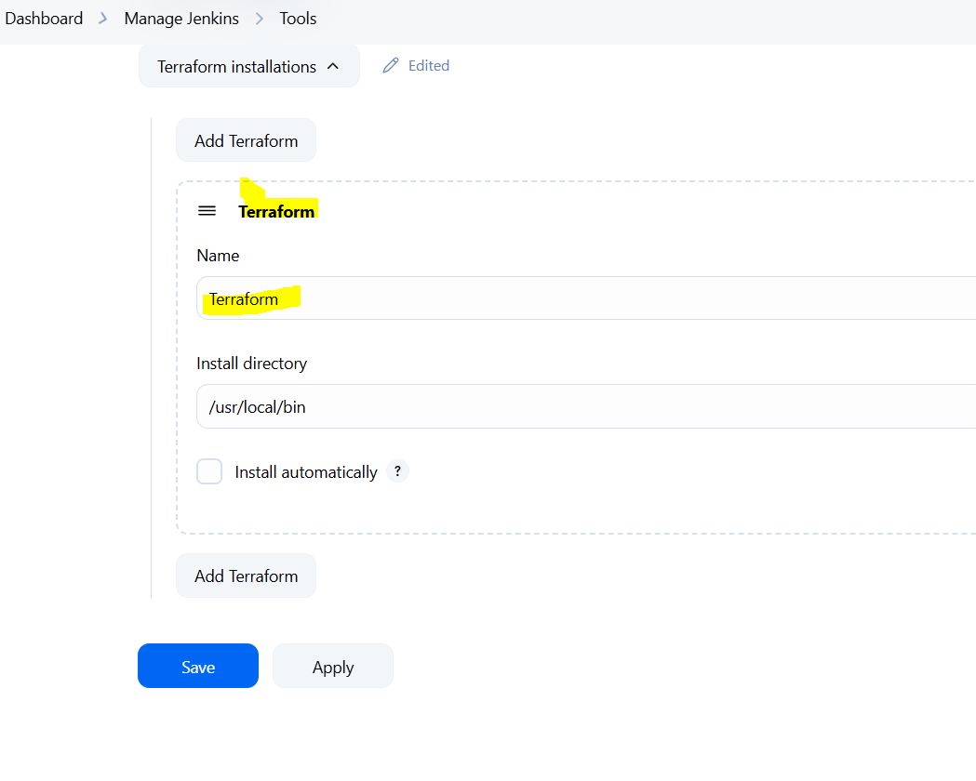

Template in main.tf of the git repo.

provider "aws" {
region = "us-east-1"
}

resource "aws_iam_user" "admin_user" {
name = "jenkins"
tags = {
description = "created from local"
}
}

resource "aws_iam_policy" "admin_policy" {
name = "Admin_Users_policy"
policy = file("admin-policy.json")
}

resource "aws_iam_user_policy_attachment" "admin_policy_attachment" {
user = aws_iam_user.admin_user.name
policy_arn = aws_iam_policy.admin_policy.arn
}

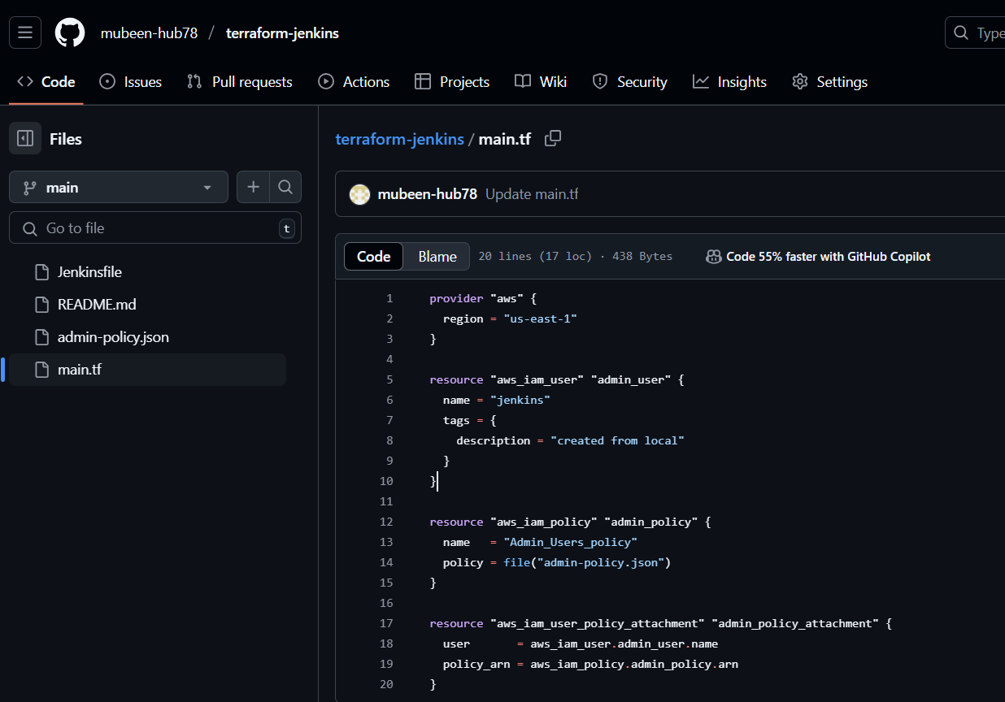

Policy file to be added in git repo admin-policy.json.
{
"Version": "2012-10-17",
"Statement": [
{
"Sid": "1234567890",
"Effect": "Allow",
"Action": "*",
"Resource": "*"
}
]
}

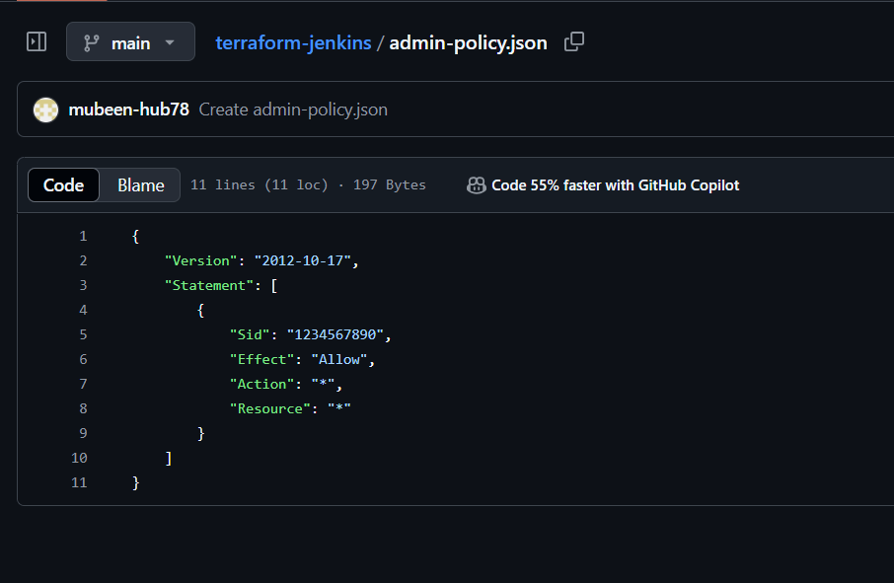

Need configure access key and secret key in Jenkins credentials.
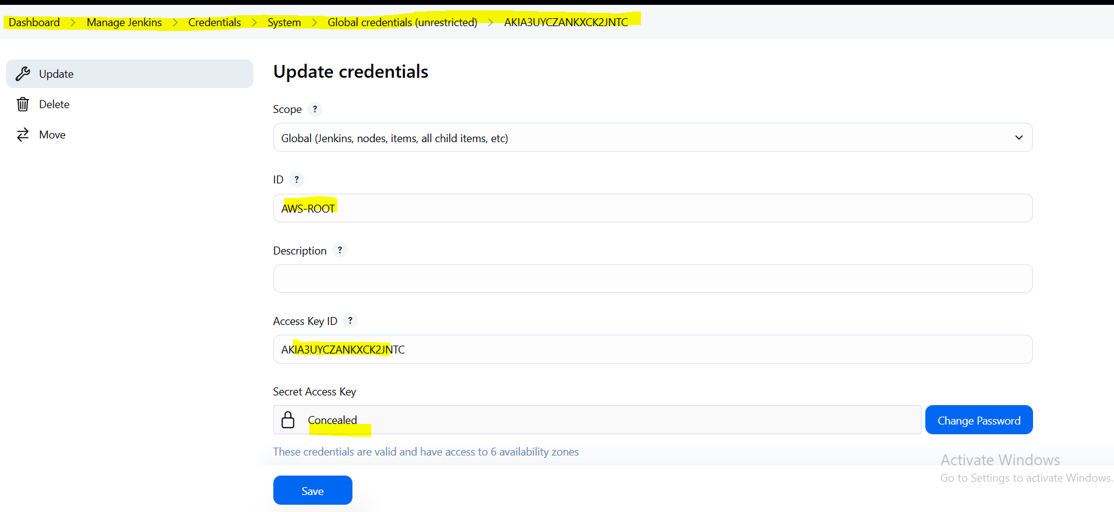

Create a job with name Terraform.
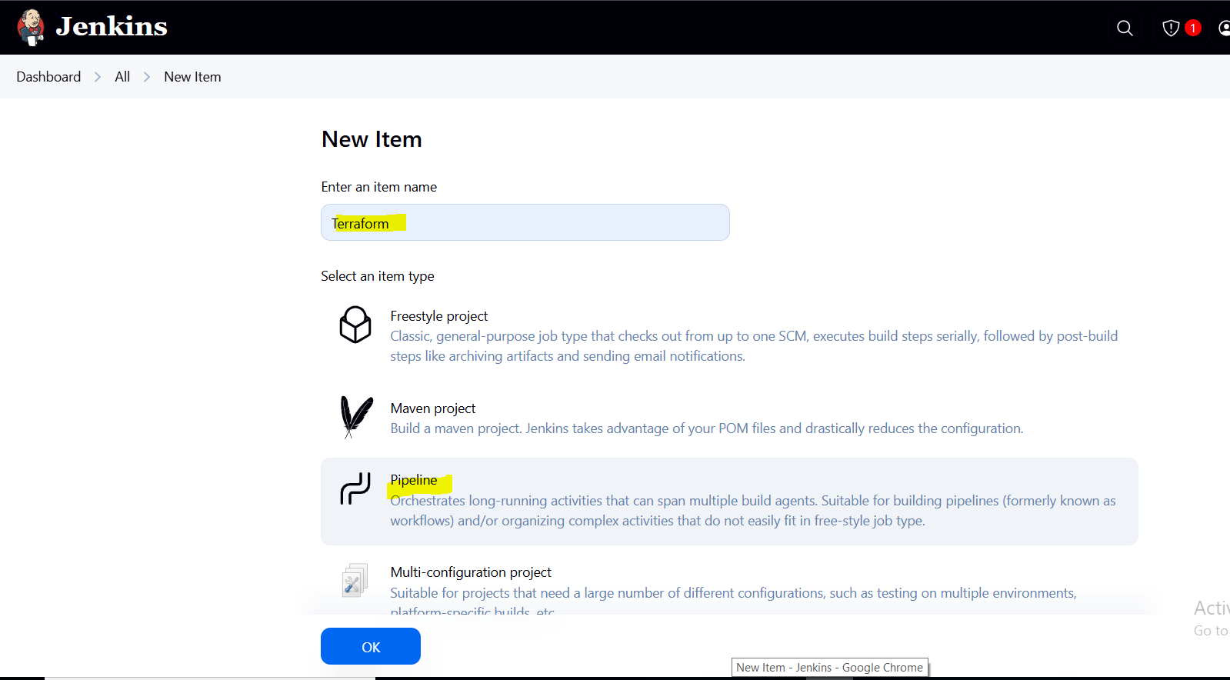

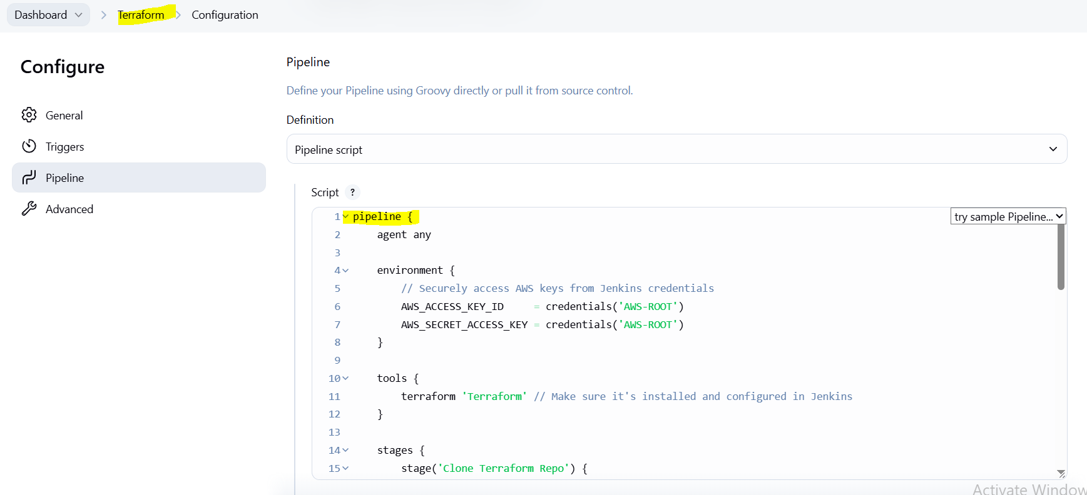

Pipeline used:

pipeline {
agent any

environment {
// Securely access AWS keys from Jenkins credentials
AWS_ACCESS_KEY_ID = credentials('AWS-ROOT')
AWS_SECRET_ACCESS_KEY = credentials('AWS-ROOT')
}

tools {
terraform 'Terraform' // Make sure it's installed and configured in Jenkins
}

stages {
stage('Clone Terraform Repo') {
steps {
git branch: 'main', url: 'https://github.com/mubeen-hub78/terraform-jenkins.git'
}
}

stage('Terraform Init') {
steps {
sh 'terraform init'
}
}

stage('Terraform Validate') {
steps {
sh 'terraform validate'
}
}

stage('Terraform Plan') {
steps {
sh 'terraform plan'
}
}

stage('Terraform Apply') {
steps {
sh 'terraform apply -auto-approve'
}
}
}

post {
success {
echo '✅ Terraform applied successfully.'
}
failure {
echo '❌ Terraform failed. Check logs.'
}
}
}

Explanation:
pipeline – This is the root block that defines the entire Jenkins pipeline script. It holds all the configurations and stages to be executed.
agent – Tells Jenkins where to run the pipeline. agent any means it can run on any available Jenkins node (master or agent).
environment – Sets up environment variables like AWS_ACCESS_KEY_ID and AWS_SECRET_ACCESS_KEY, which are securely pulled from Jenkins credentials. These variables are available throughout the pipeline.
tools – Defines the tools Jenkins needs for this job. Here, it specifies terraform, which Jenkins will install/use during execution.
stage 1 (Clone Terraform Repo) – This stage pulls the Terraform code from the GitHub repository using the git command.
stage 2 (Terraform Init) – Initializes the Terraform working directory. It downloads required provider plugins and sets up the backend if configured.
stage 3 (Terraform Validate) – Validates the syntax and structure of the Terraform configuration files. It ensures the code is written correctly before proceeding.
stage 4 (Terraform Plan) – Creates an execution plan, showing what Terraform will do without actually making any changes.
stage 5 (Terraform Apply) – Applies the planned infrastructure changes automatically without prompting for confirmation (-auto-approve).

post – This block defines steps to run after the main pipeline stages finish.
- On success: prints a success message.
- On failure: prints a failure message to help in troubleshooting.

Now run the job.

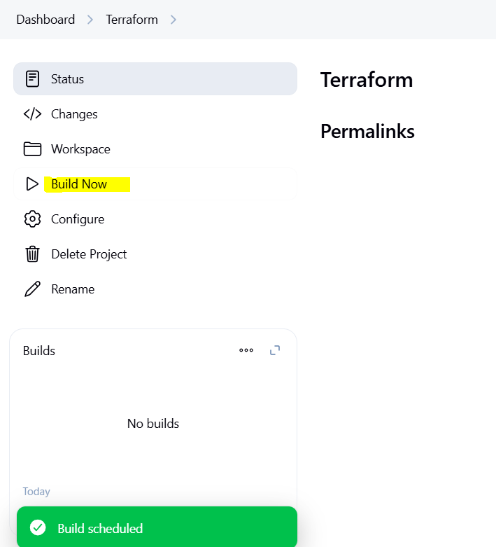

Console Output.
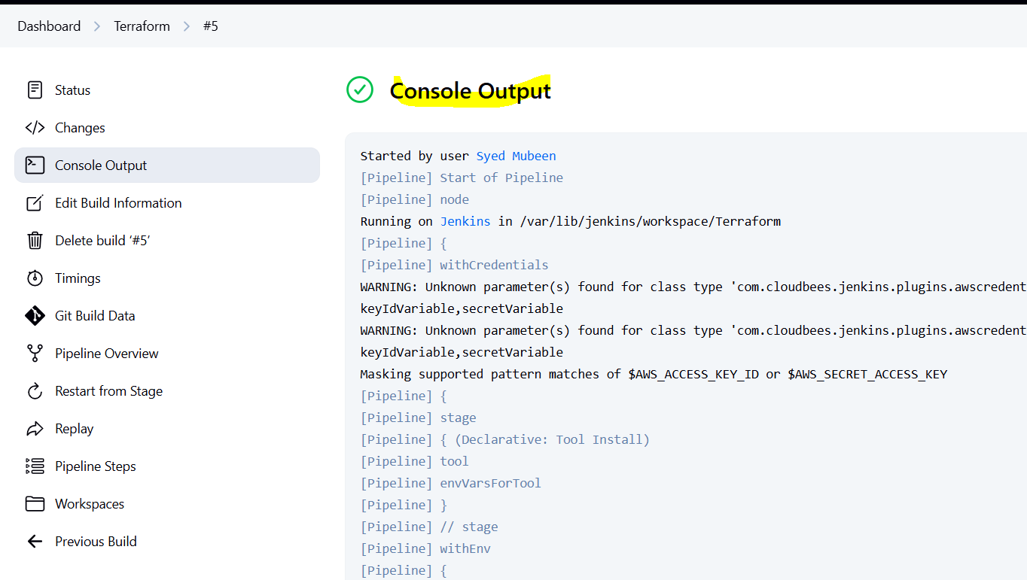
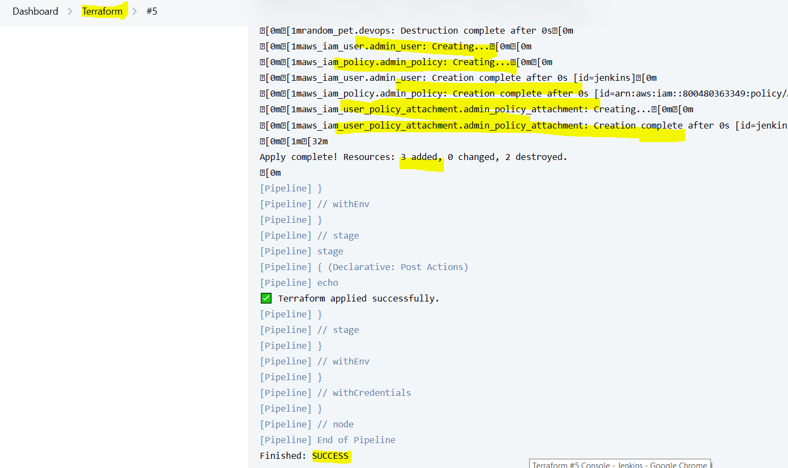

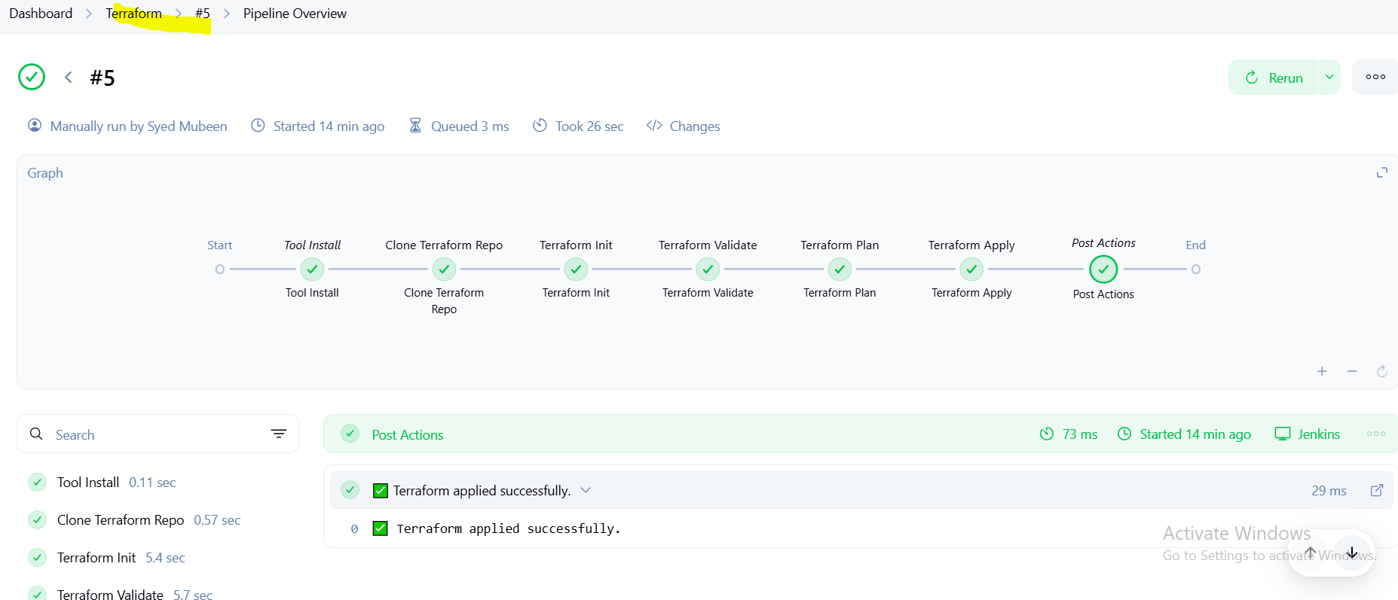

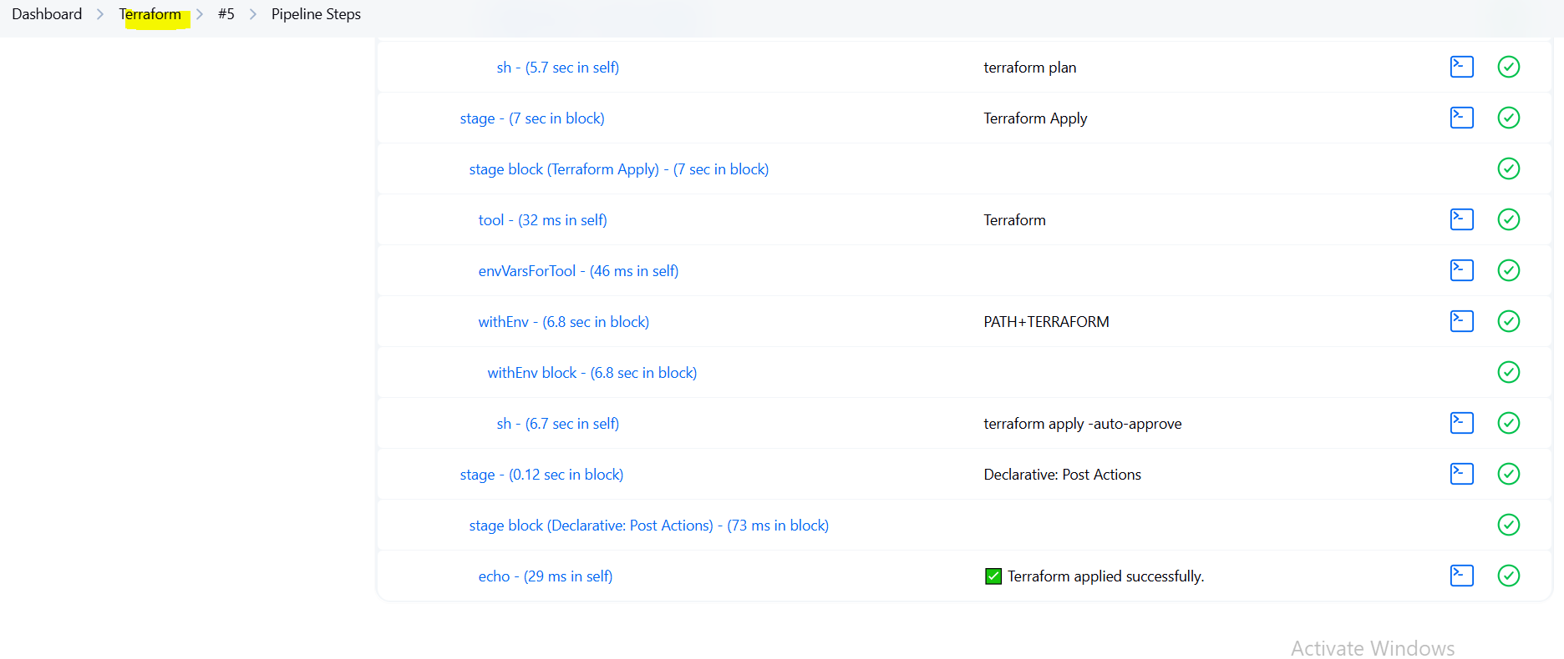

Verifying at console.
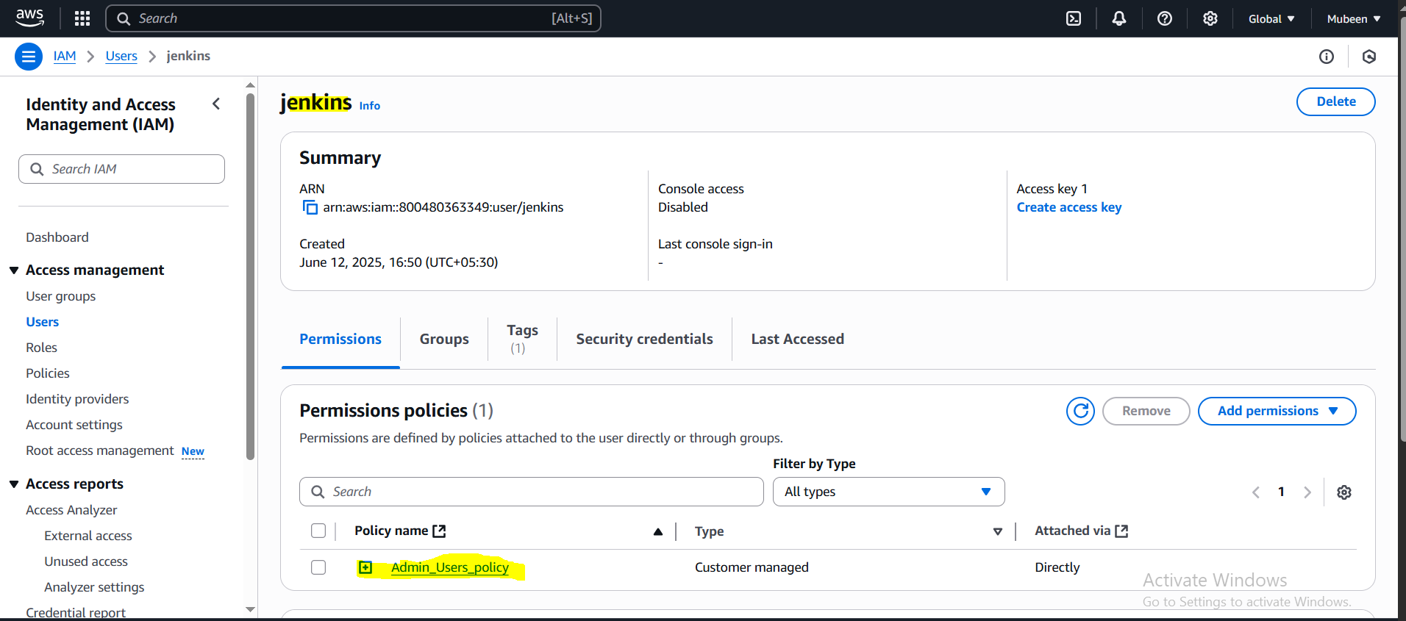
4) Create CICD pipeline for Nodejs Application. https://github.com/betawins/Trading-UI.git
Installing Prerequisites and dependencies for Nodejs.

sudo apt update – Updates the local package list to get the latest versions.
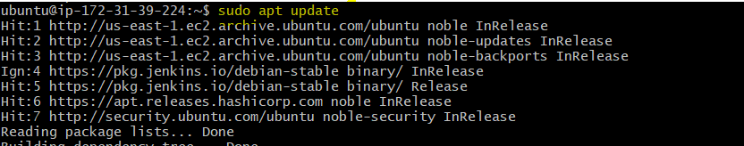
sudo apt install nodejs npm -y – Installs Node.js runtime and npm package manager.
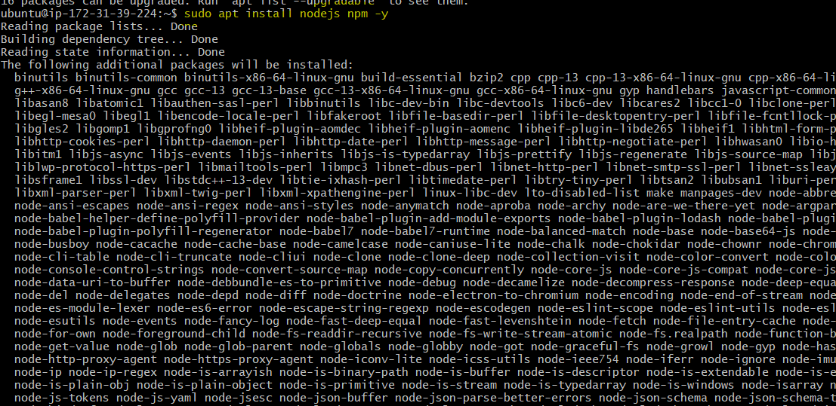
node -v – Verifies Node.js installation by checking its version.
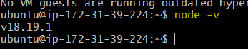
npm -v – Verifies npm installation by checking its version.
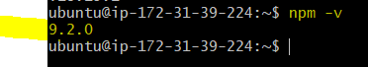

Install Nodejs plugin and configure in Jenkins.

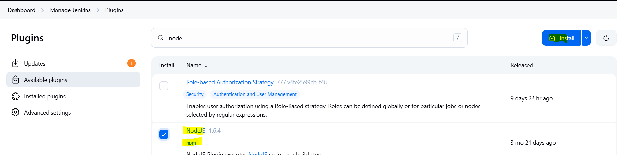

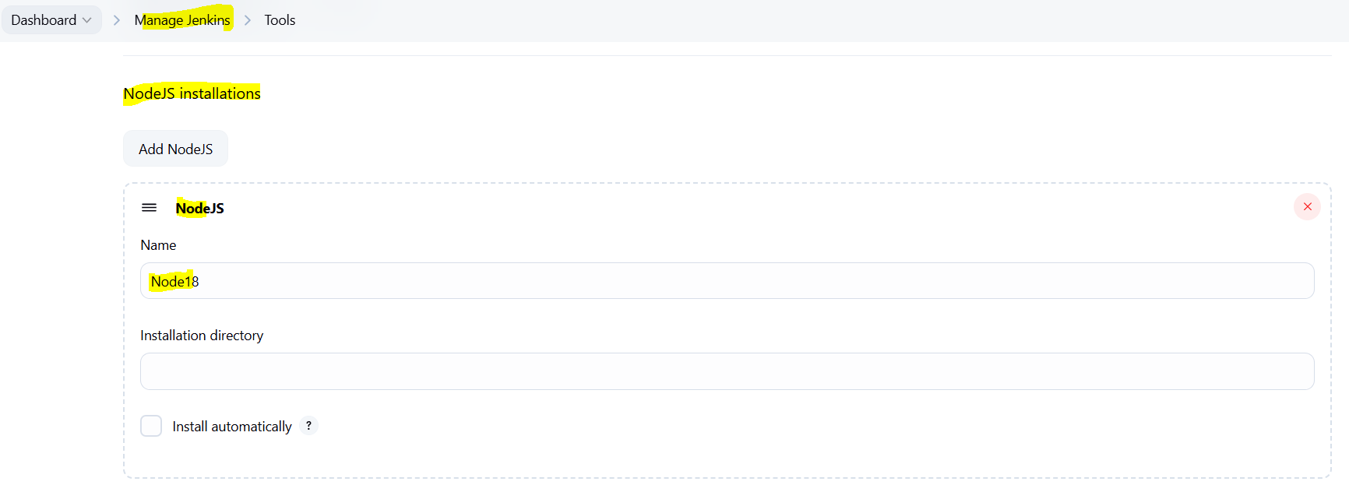

Create a new pipeline job.
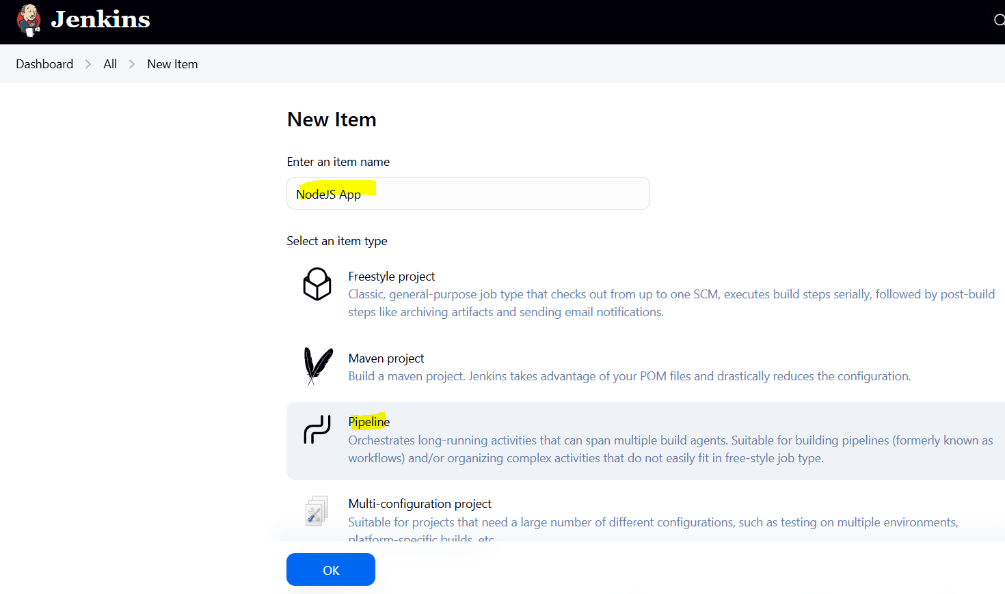

Configure the job with pipeline.
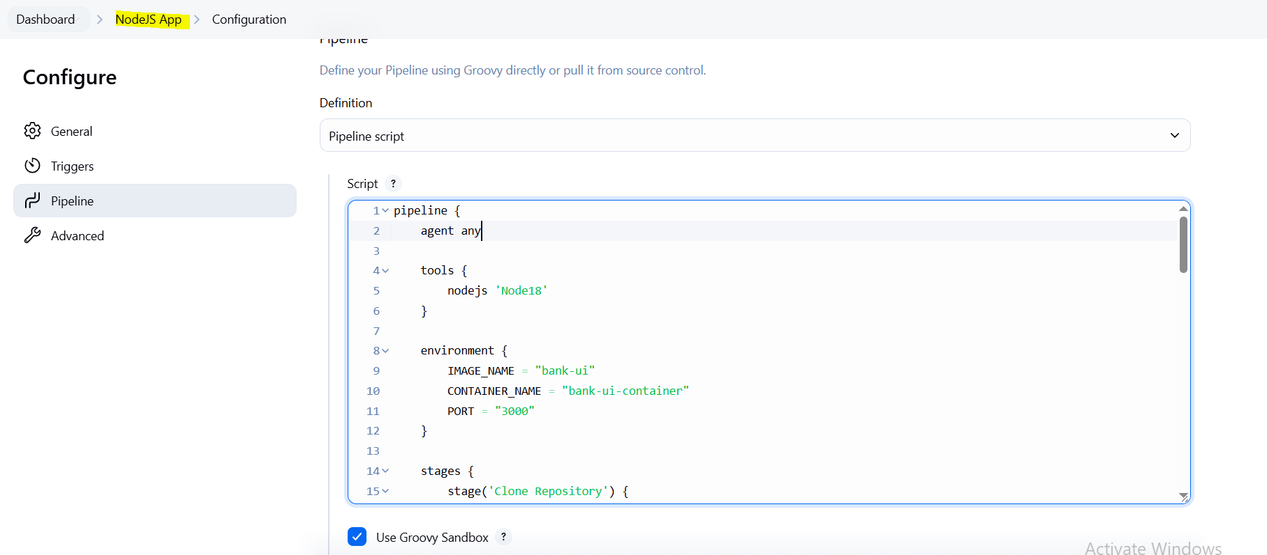

Pipeline used:

pipeline {
agent any

tools {
nodejs 'Node18'
}

environment {
IMAGE_NAME = "bank-ui"
CONTAINER_NAME = "bank-ui-container"
PORT = "3000"
}

stages {
stage('Clone Repository') {
steps {
git branch: 'master', url: 'https://github.com/mubeen-hub78/Trading-UI.git'
}
}

stage('Install Dependencies') {
steps {
sh '''
rm -rf node_modules package-lock.json
npm install --legacy-peer-deps
'''
}
}

stage('Build Application') {
steps {
withEnv(['NODE_OPTIONS=--openssl-legacy-provider', 'CI=false']) {
sh 'npm run build'
}
}
}

stage('Build Docker Image') {
steps {
sh '''
echo "FROM nginx:alpine" > Dockerfile
echo "COPY build /usr/share/nginx/html" >> Dockerfile
docker build -t $IMAGE_NAME .
'''
}
}

stage('Run Docker Container') {
steps {
sh '''
docker rm -f $CONTAINER_NAME || true
docker run -d --name $CONTAINER_NAME -p $PORT:80 $IMAGE_NAME
'''
}
}

stage('Print URL') {
steps {
sh 'echo "✅ App running at: http://$(curl -s ifconfig.me):$PORT"'
}
}
}

post {
success {
echo '✅ Deployment complete. Access your app via public URL.'
}
failure {
echo '❌ Deployment failed. See logs.'
}
}
}

Explanation:
tools – Specifies Node.js version (Node18) required for building the application.
environment – Sets Docker image/container names and port number used in the pipeline.
Stage: Clone Repository – Clones the React project from the specified GitHub repository.
Stage: Install Dependencies – Installs all npm dependencies, bypassing strict peer dependency checks.
Stage: Build Application – Builds the React application into static files using npm run build.
Stage: Build Docker Image – Creates a Dockerfile and builds an image containing the built React app using NGINX.
Stage: Run Docker Container – Stops any existing container and runs the new image on the specified port.
Stage: Print URL – Prints the public IP with port where the app is accessible.
post: success – Prints success message after successful deployment.
post: failure – Prints failure message if any stage fails.

Click on Build Now.
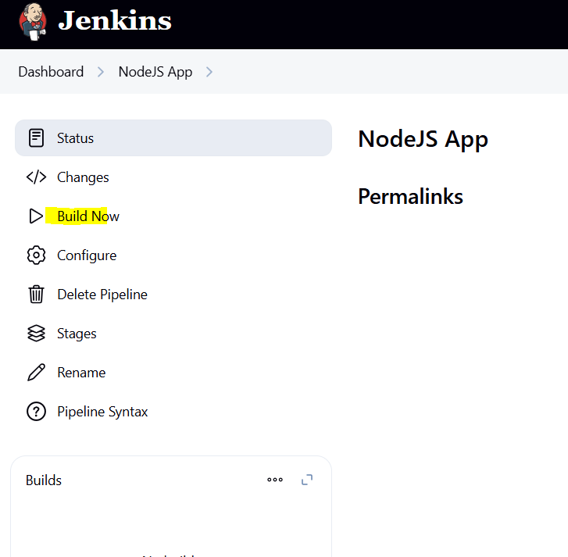
Console Output.
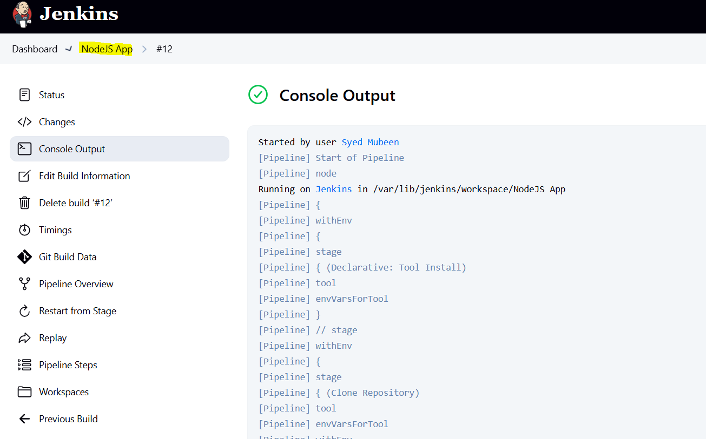

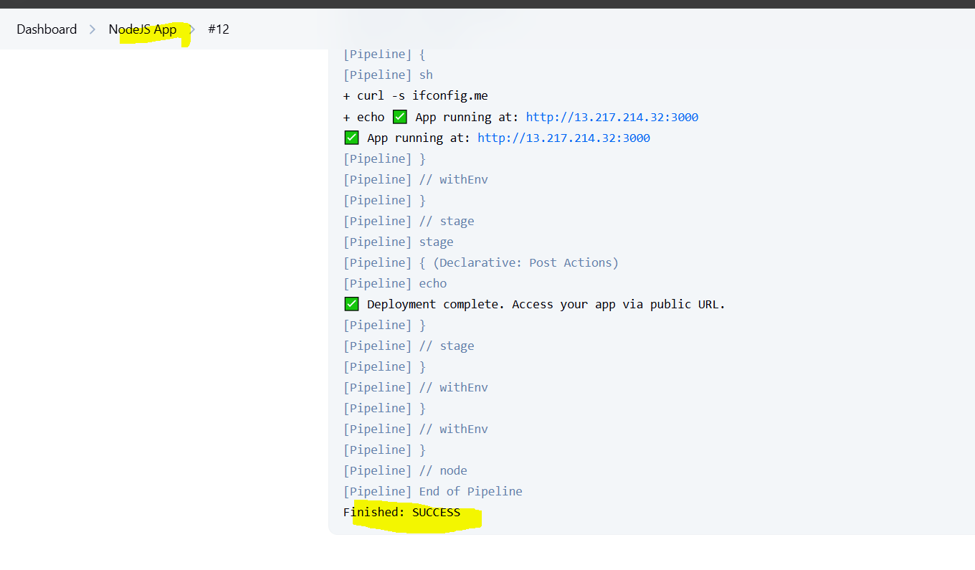

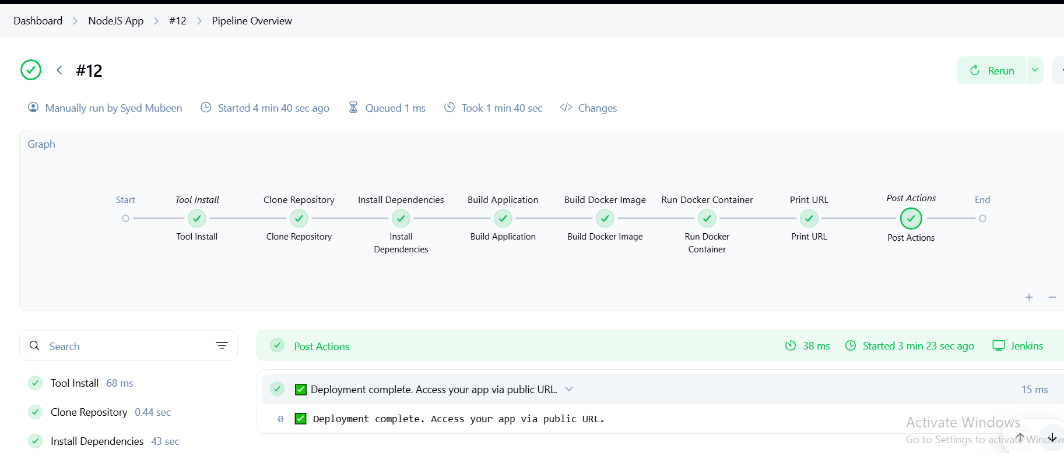

PUBLIC IP URL:3000
We use port 3000 because it's the default port for React development servers before they are served through production servers like Nginx.

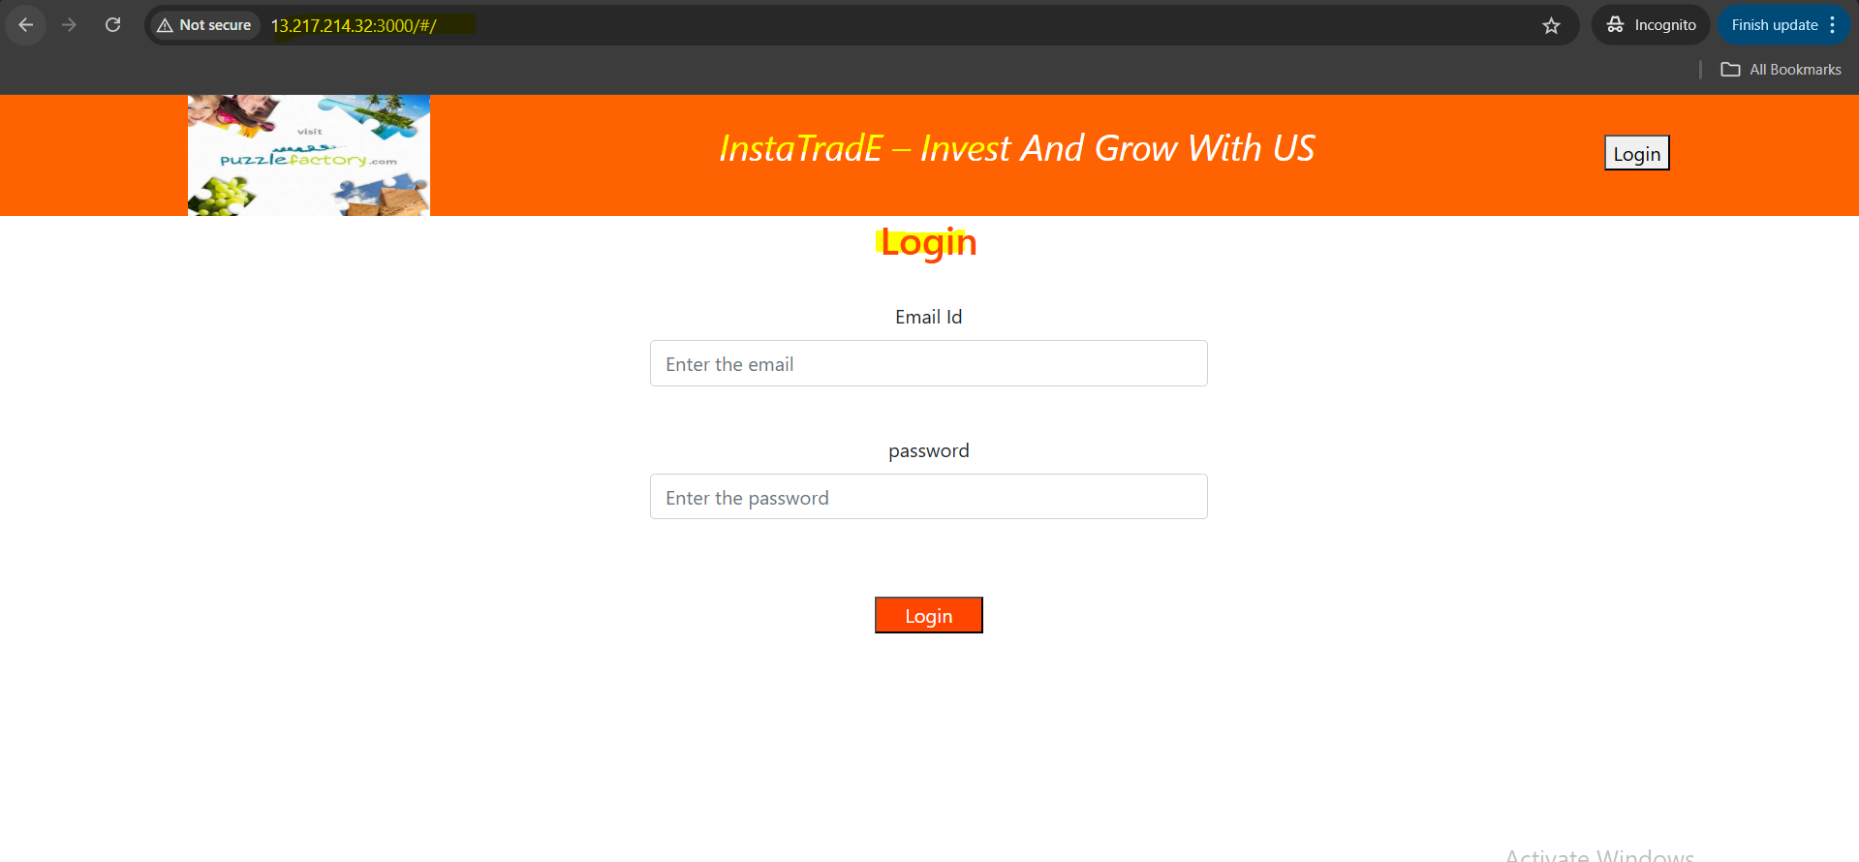

5) Explain 10 Maven commands.
1. mvn clean –
Deletes the target/ directory (build output), ensuring a clean build environment.
2. mvn compile –
Compiles the source code of the project (usually from src/main/java).
3. mvn test –
Runs the unit tests present in the project using a testing framework like JUnit/TestNG.
4. mvn package –
Packages the compiled code into a .jar or .war file based on the pom.xml configuration.
5. mvn install –
Installs the built artifact into the local Maven repository so other projects can reuse it.
6. mvn deploy –
Deploys the built artifact to a remote Maven repository (e.g., Nexus, Artifactory).
7. mvn validate –
Checks if the pom.xml is correct and all necessary information is available.
8. mvn site –
Generates project documentation (reports like dependencies, test coverage, etc.).
9. mvn dependency:tree –
Displays the project’s dependency hierarchy to troubleshoot version conflicts.
10. mvn versions:display-dependency-updates –
Shows available updates for project dependencies — useful for maintaining the latest versions.

THE-END

